2.2 Sets
The simplest way to describe a collection of related objects is a set. Think of the set S as a container where an object x is something that S contains.
We write $x∈S$ to denote that x is contained in S. We also say "x is a member of S", "x is an element of S" or more simply "x is in S."
$$S=\{x_{1}, x_{2}, …,x_{n}\}$$
Suppose there is some property p that some of the elements of a set S have. We can describe the set of all elements of S that have property p as $\{x∈S|x has property p\}$.
This is sometimes called "set builder" notation, because it explains how to build a list of all the elements of a set.
Example: Let $A=\{1,2,3,4,5,6,7,8\}$. Then $2∈A and 9∉A$. If $B=\{x∈A|x is odd\}$, then the elements of B are 1,3,5,7.
Example: There are some common sets that have specific names. The set of integers is denoted by $Z$, and the set of positive integers, or natural numbers is written as N. Note that $0∈Z, but 0∉\text{N}$. We use R for the set of real numbers, and Q for the set of rational numbers.
The language of sets is convenient for describing groups of objects that are related by some common property. Often some property implies another; for example, all integers are real numbers. In terms of sets, this means that the set Z is contained in the set R. In general, the predicate logic statement that $(∀x)(x∈A→x∈B$) is written as $A⊆B$ and we can say "A is contained in B" or "A is a subset of B" or "B contains A".
$$N⊆Z⊆Q⊆R$$
The empty set $∅$ is the set that contains no elements. Therefore, the empty set is a subset of any set, that is $∅⊆X for all X$.
NEW NOTATION, HOORAY!!!!
All the logic connectives from Chapter 1 have counterparts for set notation.
For a set X, $\left|X\right|$ denotes the number of elements in the set X.

The union $A∪B$ of two sets A and B is the set containing all the elements of both A and B put together. An element is the union of two sets A and B if the element is in A, or B, or both.
$$A∪B=\{\left(x∈A\right)∨\left(x∈B\right)\}$$
So these two statements are equivalent and can replace one another when proving statements.
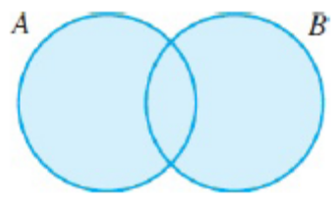
The intersection $A∩B$ is the set containing all the elements that A and B have in common. In order for an element to be in the intersection of A and B, the element must be in both sets.
$$A∩B=\{x|\left(x∈A\right)∧\left(x∈B\right)\}$$
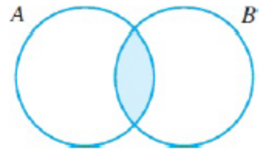
The universal set U is the default domain of all sets. In other words, every set is a subset of the universal set. If we know the domain is, we can speak of the complement A' of A, which is the set $A^{'}=\{x∈U|x∉A\}$.
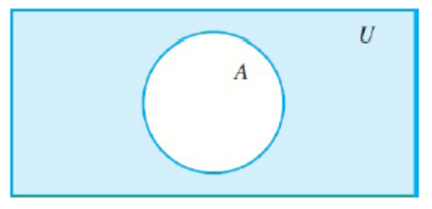
Cartesian Product
Given two sets, A and B, we can build a new set called their Cartesian product $A×B$. The Cartesian product is just the set of all ordered pairs where the first item comes from the first set and the second item comes from the second set.
$$A×B=\{(a,b)|a∈A and b∈B\}$$
This can be extended to ordered triples, quadruples, and so on.
The magnitude of a set A is $\left|A\right|$ and is the number of elements in a set.
Two ordered pairs are equal if and only if their corresponding parts are equal.
$$\left(a,b\right)=\left(c,d\right) ⟺a=c and b=d$$
The set of ordered pairs of all real numbers is $R×R$. This is sometimes referred to as the Cartesian plane.
The power set $P(S)$ of the set S is the set of all subsets of S.
$$P\left(S\right)=\{X|X⊆S\}$$
Note that the empty set is a member of P(S), regardless of S.
Example: Let $A=\left\{1,2,3,4,5\right\}, B=\{4,5,6,7,8\}$. Suppose the universal set is $U=\{1,2,…,10\}$. Find the following:
$A∪B. A∩B. B^{'}. \left(A∩B\right)×A. P\left(A∩B\right). B\backslash A. \left|A'\right|$.
$A∪B$ = This is the set of all elements in A and all the elements in B. We do not, however, need to repeat any values that show up in both. Just list those once. So $A∪B=\{1,2,3,4,5,6,7,8\}$
$A∩B$ = This is the set of all elements that show up in BOTH A and B. So we only list the elements that are repeated. So $A∩B=\{4,5\}$
$B'$ = This is the set of all the elements inside our universal set that are NOT in the set B. So $B^{'}=\{1,2,3,9,10\}$
$\left(A∩B\right)×A$ = This is the set of all ordered pairs where the first elements come from $A∩B$ and the second elements come from $A$. So our first element can be 4 or 5. Our second element can be 1,2,3,4 or 5. So $\left(A∩B\right)×A=\{\left(4,1\right),\left(4,2\right),\left(4,3\right),\left(4,4\right),\left(4,5\right),\left(5,1\right),\left(5,2\right),\left(5,3\right),\left(5,4\right),\left(5,5\right)\}$
$P\left(A∩B\right)=$ This is the set of all possible subsets of $A∩B$. So imagine you're standing in front of a table with a 4 and a 5 on it. You want to list all the different combinations of these elements. You can take none of them. (That's the empty set, $∅$). You can take just the 4, {4}. You can take just the 5, {5}. And lastly you can take both of them, {4,5}. So $P\left(A∩B\right)=\{∅, \left\{4\right\}, \left\{5\right\}, \left\{4,5\right\}\}$.
$B\backslash A$ = This is the set of all elements in B that are NOT in A. One way to look at this is to think of it as starting with all the elements of B. {4,5,6,7,8}. And then eliminate any of those that are in the set A {1,2,3,4,5}. So $B\backslash A=\{6,7,8\}$
$\left|A'\right|=$ This is the magnitude of the set A'. That means the number of elements in the set A'. So first we find the set A', which is all the elements in our universal set that are NOT in A. So $A^{'}=\{6,7,8,9,10\}$. Now count the number of elements in that set, so $\left|A'\right|=5$.

HOMEWORK!! #1, 2, 3, 5-9, 15-17, 21, 22

